Information systems Assignment

(6G4Z1103)

Part 2

**Alexander Harrison (17080341)**

**Lewis Frater (17081955)**

**Callum Flanagan (17028406)**

**Rebecca Clarke(17032866)**

**Antreas Christofi(17083606)**

2017-2018

Complete a prioritised group use case diagram (UCD) of the new system (that allows for the activities that take place in the current system), using the ‘MOSCOW’ system of prioritisation.  
  
Provide a commentary explaining the decisions made when creating the UCD and a summary of what has been learned in the process.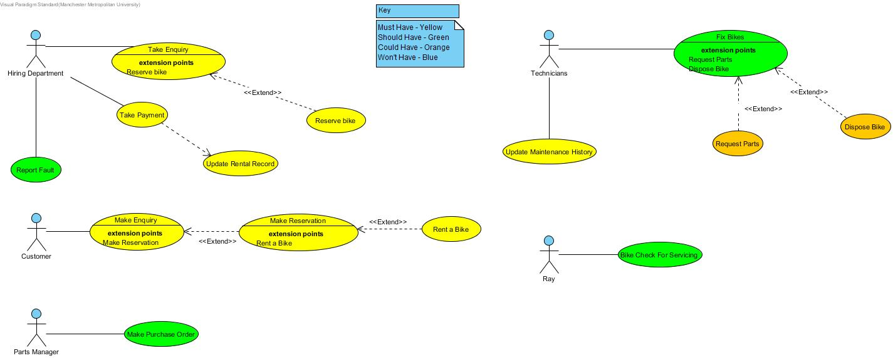

1. Customer Makes a general enquiry via phone, so to get informations about a bike he is interested in. We connected the Actor(Customer) to “Make Enquiry” Use Case“ and we linked it with an extend “Make Reservation” Use Case so when the Hiring Department does it’s work(collect necessary information) Customer can reserve a bike. That’s why we linked “Rent a Bike” as an extend Use Case in “Make Reservation” Use Case.
2. Hiring Department takes the enquiry from the Customer, then collects his details and informs the Customer about the bike he is interested in. That’s why we created a “Take Enquiry” Use Case which is linked with a “Reserve Bike” Use Case in case Customer decides to reserve it. Therefore, if the Customer wants to buy the bike he reserved (or not) he calls Hiring Department proceeds to payment and the Hiring Department updates Rental Record then. That’s why we included “Update Rental Record” connected to “Take Payment” Use Case. Afterall, if Customers have problems with their bikes, they can call Hiring Department and report the problem to them, so the HD with their turn will inform Technicians about.
3. Technicians collects the bikes with their turn and try to fix them. If they need any part for fixing the bikes they have to refer to Parts Manager, That’s why we linked an extended Use Case to “Fix Bikes” Use Case. Otherwise, if they can’t fix the bike, they have to dispose it and inform Ray and the Hiring Department. For that, we linked the “Dispose Bike” Extend Use Case on the “Fix Bike” Use Case. Also, they get the bikes that needs service from Ray who inspects them every Friday.
4. Ray checks all bikes for serving every Friday so they will be ready for sell. If a bike hasn’t been for service for over a month he send it over to the Technicians. We connected “Bike Check for Serving” Use Case to Ray.
5. Parts Manager is responsible for supplying the Technicians with parts when needed for fixing/repairing bikes. We connected “Make Purchase Order” Use Case to Parts Manager.

Complete one use case specification per student (each use case spec should make use of the use case template provided on Moodle and include an entity relationship diagram (ERD)); ensure that you cover the core use cases

By Alexander Harrison

|  |
| --- |
| **Use Case: Bike Check for Servicing** |
| Owner: Ray |
| **Pre-Conditions** |
| Ray will perform the checks on a friday of every week. |
| **Post-Conditions** |
| The bikes will all be checked and then Ray will report it back to the technicians anything that needs to be fixed. |
| **Primary Path** |
| 1. It is a friday 2. The bikes are checked by Ray 3. Ray finds faults 4. Faults are reported to the technicians |
| **Alternate Path** |
| 1. It is a friday 2. The bikes are checked by Ray 3. Ray doesn’t find any faults |
| **Notes** |
|  |
|  |
|  |

By Lewis Frater

|  |
| --- |
| **Use Case: Take Payments** |
| Owner: Hiring Department |
| **Pre-Conditions** |
| Customer has made an enquiry and wants to hire or reserve a bike  The bike the customer wants is in stock |
| **Post-Conditions** |
| If payment is successful, receipt is sent to customer.  Bike gets rented out.  Update rental record. |
| **Primary Path** |
| 1. Customer makes an enquiry via phone 2. Hiring department tells customer bike is in stock 3. Ask for payment details 4. Process payment 5. Send receipt |
| **Alternate Path** |
| 1. Customer makes enquiry via phone 2. Hiring department sends/tells customer bike hiring info 3. Customer decides which bike to hire 4. Ask for payment details 5. Process Payment 6. Send Receipt |
| **Notes** |
|  |

**By Callum Flanagan**

|  |
| --- |
| **Use Case: Take Enquiry** |
| Owner: Hiring Department |
| **Pre-Conditions** |
| Customer contacts Rays Rentals |
| **Post-Conditions** |
| Can lead to handing out information  Can lead to hiring a bike |
| **Primary Path** |
| 1. Customer contacts via phone 2. Customer will ask about a certain bike and gather information 3. Hiring department will check if the bike is availible, if so 4. Customer will hire or reserve a bike |
| **Alternate Path** |
| 1. They could email to make an enquiry 2. They can walk into the store to make an enquiry |
| **Notes** |
|  |

**By Callum Flanagan**

|  |
| --- |
| **Use Case: Make Purchase Order** |
| Owner: Parts Manager |
| **Pre-Conditions** |
| Checks parts list |
| **Post-Conditions** |
| Receive bike part and send to technician |
| **Primary Path** |
| 1. Receives information about a fault, 2. Checks to see if the part is in stock 3. If they haven't got the part to fix the bike then order the part . 4. Then the part will be delivered from the supplier 5. The technician will then fix the bike |
| **Alternate Path** |
| Bike is unable to be fixed, therefore the bike will no longer be used.  Then the customer will be informed about the bike. |
| **Notes** |
|  |

**By Rebecca Clarke**

|  |
| --- |
| **Use Case: Fix Bike** |
| Owner: Technician |
| **Pre-Conditions** |
| Bike needs repair, technician receives bike with faults, orders parts and fixes it. |
| **Post-Conditions** |
| Bikes Get Repaired and returned |
| **Primary Path** |
| 1. Technician department is notified of the repair being needed. 2. Technician inspects bike and requests parts for repairs 3. Technician receives parts and fixes bike. 4. Maintenance return bikes |
| **Alternate Path** |
| 1. Technician department is notified of the repair being needed 2. Technician inspects bike 3. Technician has parts in stock 4. Technician fixes bike 5. Technician returns bike |
| **Notes** |
|  |

**By Rebecca Clarke**

|  |
| --- |
| **Use Case: Order Parts** |
| Owner: Techician |
| **Pre-Conditions** |
| Bike needs repair, technician receives bike with faults |
| **Post-Conditions** |
| Parts Manager makes purchase order |
| **Primary Path** |
| 1. Technician department is notified of the repair being needed 2. Technician Receives Bike 3. Technician Inspects Bike 4. Technician tells parts manager which parts he requires |
| **Alternate Path** |
|  |
| **Notes** |
|  |

**By Antreas Christofi**

|  |
| --- |
| **Use Case: Make Reservation** |
| Owner: Customer |
| **Pre-Conditions** |
| Customer calls in and makes a general enquiry for a bike. |
| **Post-Conditions** |
| Ray’s Rentals informs the customer about the bike.  Rental Record checks for bike’s availability.  Hiring Department informs Customer. |
| **Primary Path** |
| 1. Customer calls in and makes a general enquiry for a bike. 2. Ray’s Rentals informs the customer about the bike. 3. Customer decides if he wants to reserve a bike. 4. Reservation details as jotted down from staff along with customer details. 5. Rental Record checks for bike’s availability and informs Hiring Department. 6. Hiring Department informs Customer that his choice of bike is available. 7. Customer Decides if he wants to Reserve a bike. |
| **Alternate Path** |
| 1. Customer calls in and makes a general enquiry for a bike. 2. Ray’s Rentals informs the customer about the bike. 3. Customer decides if he wants to reserve a bike. 4. Reservation details as jotted down from staff along with customer details. 5. Rental Record checks for bike’s availability and informs Hiring Department. 6. Hiring Department informs Customer that his choice of bike isn’t available. |
| **Notes** |
|  |

**By Antreas Christofi**

|  |
| --- |
| **Use Case: Update Maintenance History** |
| Owner: Technicians |
| **Pre-Conditions** |
| Bike has been fixed.  Bike has been serviced. |
| **Post-Conditions** |
| They ask Part Manager for the needed part(s).  They fix the bike.  They update Maintenance History. |
| **Primary Path** |
| 1. Hiring Department informs Technicians for a customers Bike problem. 2. Technicians asks Part Manager for the needed part(s). 3. Technicians fix the bike. 4. They Update Maintenance History. |
| **Alternate Path** |
| 1. Hiring Department informs Technicians for a customers Bike problem. 2. Technicians asks Part Manager for the needed part(s). 3. Technicians inform Hiring Manager that they can’t fix the bike’s problem. 4. They update Maintenance History |
| **Notes** |
|  |

Complete a top-down ERD of the system

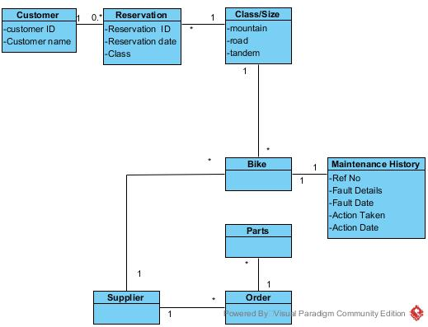

Include a completed RDA of each the two documents provided in the case study and a bottom up ERD of the merged RDAs

Appendix A - Bike Record

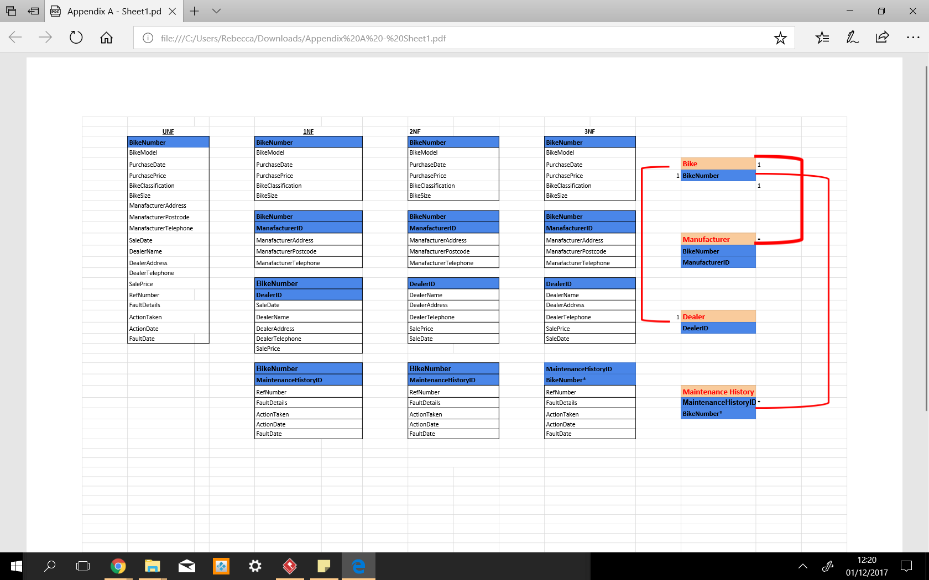

Appendix B - Rental Record



Bottom up ERD

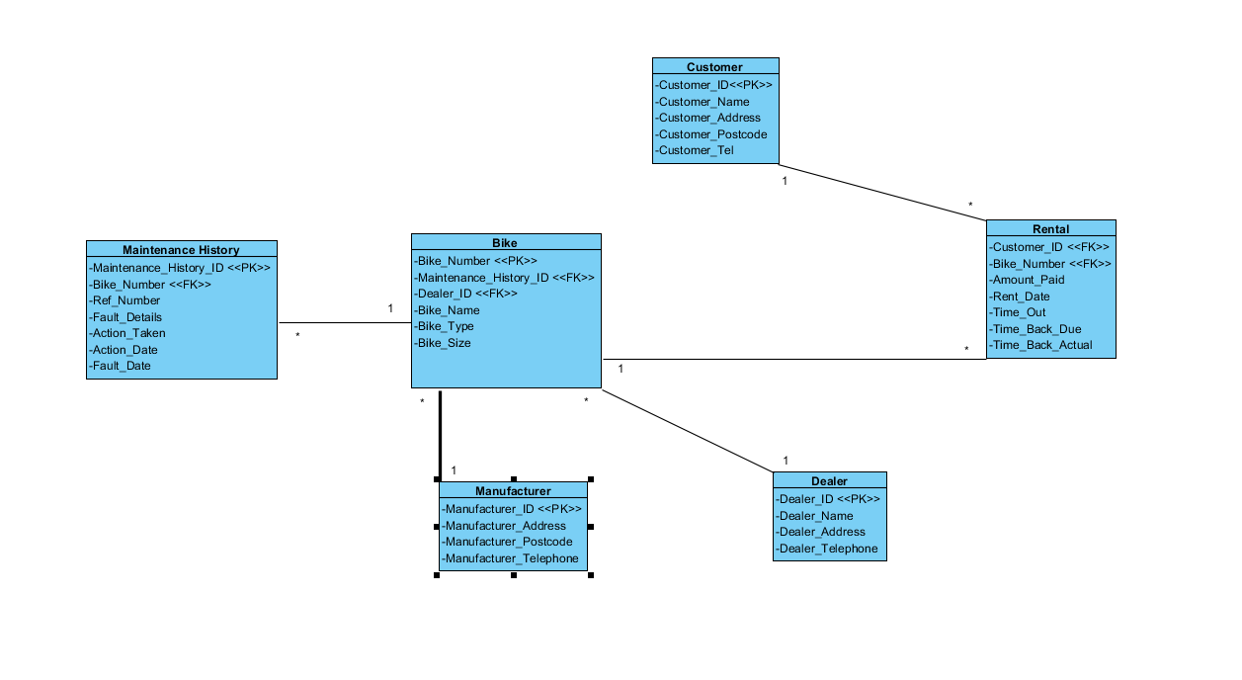

Finalised ERD

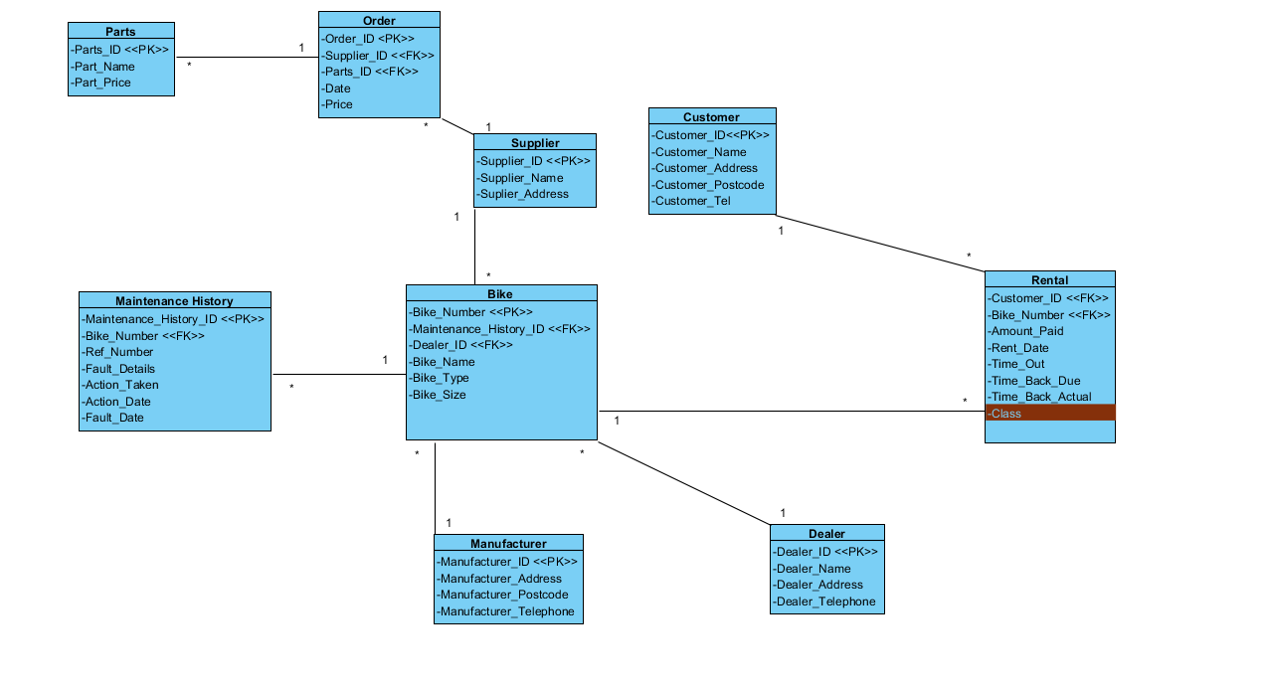

Parts to order

We did this so that there wasn’t a many to many relationship and you can see what has been ordered.

Order to supplier

We have this so that the supplier will be linked to the order.

Supplier to bike

This is to link all the suppliers with the bikes they provide.

Bike to Maintenance history

This is where every Technician's work on bikes gets saved so to keep everything sorted.

Bikes to manufacturer

This is where the details of every bike’s Manufacturer are kept.

Bikes to dealer

This links to every bike’s dealer so his details will be saved.

Bikes to rental

Rental links with every bike’s ID so to be easier to inform any Customer about any bike.

Rental to customer

This is where Hiring Department informs the Customers about the bike they make an enquiry by giving them all the needed details.

Piazza

Meeting 20/11/2017 1300 hours

Library 5th Floor

Everybody turned up except Joe. Who we emailed before hand.

Completed 1 and 2, started 3, everyone to complete ERD and UC specs.

next meeting: 21/11/2017 in one hour gaps to complete 3.

Late Post for 21/11/17

Reviewed 1+2, asked for feedback on these and needed to re-do this

Meeting 22/11/2017 1300 hours

JD C.012

Everybody turned up except Joe. Who we emailed before hand.

Completed 1+2 In own time

Everyone has been given work for number 3, this will be completed by next meeting

Next Meeting TBA

Date 24/11/2017 Time 2:30

2.03

Started the ERD

Attendance

Lewis and Alexander

Absent

Rebecca, Callum and Andreas

Next meeting Monday 3 hour gap

Complete top down and bottom up ERD

Date 27/11/2017 Time 3:00

Completed ERD's for use case specs

Attendance

Lewis, Alexander and Callum

Absent

Rebecca, Andreas

Next meeting Tuesday in our hour gaps

Put together ERD's to get a view of the whole system.

Date 28/11/2017 Time 1-4

We put most of the work into the report

Attendance

Lewis, Alexander, Callum and Rebecca

Andreas

Absent

Next meeting Friday in lesson we will finish the rest of the work and read over the report

Date 1/12/2017 Time 1-3

We finished off the ERD and put the remaining work into the report and submitted it.

Attendance

Lewis, Alexander, Callum and Rebecca Andreas

Absent